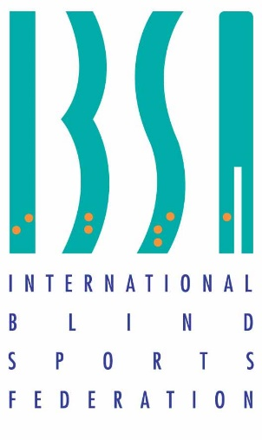
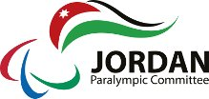

Jordan Paralympic committee
Hosts the 2021 IBSA GENERAL ASSEMBLY
Dead Sea – Jordan
OCTOBER 10- 12 /2021

Date: 5/1/2021

Dear Sirs,

Warm greetings from Jordan,

I would like to take this opportunity to invite you to attend the IBSA General Assembly on October 10-12 2021. If you have any questions or comments, don’t hesitate to contact us.

Thank you for your attention to this matter and looking forward to seeing you there.

Regards,

Secretary General
Maha Barghouthi
Information about the conference

Jordan Paralympic committee will host the General Assembly meeting of the International Blind Sports Federation (IBSA) from the 10-12/10/2021 at the Dead Sea – Jordan.

Glimpse of the Dead Sea:
The First Natural Spa in the World
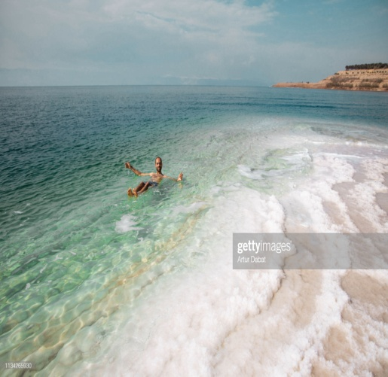
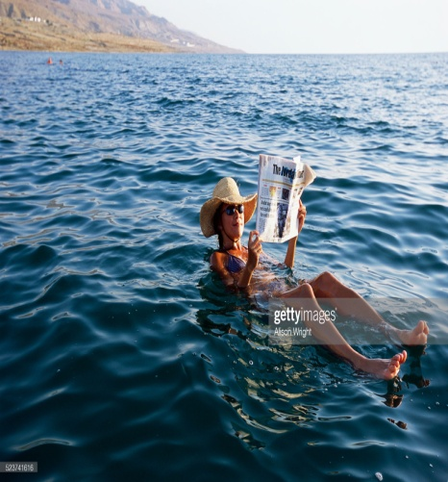

At 410 meters below sea level, the Dead Sea is the lowest place on earth. A large amount of investment in the area has provided the Dead Sea with new roads and luxurious 4 and 5 star hotels and an award winning conference center.
Studies have shown the combination of the Dead Sea water and the rich black muds have significant health benefits such as increasing blood circulation, easing discomfort from arthritis, healing allergies and revitalizing skin.

Official Hotel( 5 stars) : Hilton Dead Sea Resort & Spa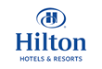
Conference venue:
King Hussein Bin Talal Convention Centre Managed by HILTON

Badges:
Each delegate will receive a name badge after registration and after paying the accommodation fees. The badge must be worn all the times during the meetings and other activities.

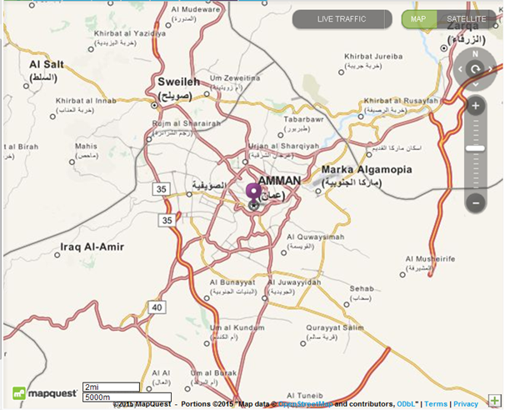

Currency:
The official currency in Jordan is the Jordanian Dinar, which is available in coins and cash. The Jordanian coin categories are: 1/2 dinar, 1/4 Dinar, 50 and 10 fills. The cash is available in different colors and sizes categories: are 1, 5 ,10,20 and 50 dinars.

Arrival details:
For all countries entering Jordan it is compulsory to pay for their visas in Amman Airport (40$), apart from some countries who require invitation letters and agreements from the Ministry of Interior – Jordan (as listed below).
For these countries listed as requiring visas before entering Jordan, please provide us Visa request form and copies of their passports and a passport photo 2 months before arrival to prepare their visas. Without these you will be unable to enter Jordan.

Visa request form
Name  (Last Name) | (First Name) | Gender  (F/M) | Passport Number | Expiration date  (DD/MM/YYYY) | Date of Birth  (DD/MM/YYYY) | Position

Transportation:
Shuttle Buses will transport delegates from Amman Airport (Queen Alia) to hotel; it usually takes about 30 minutes.
Please note that transportation to the hotel from Amman airport can only be accepted if details - hour, flight no. and country plus name is sent by 15 September to the organizers.

Residence Hotel & Accommodation
Both accommodation including full board and the meeting hall are in the same place (Hilton) which is a five stars’ hotel located at the Dead Sea.

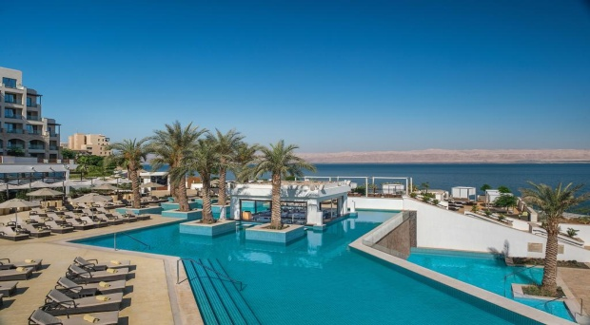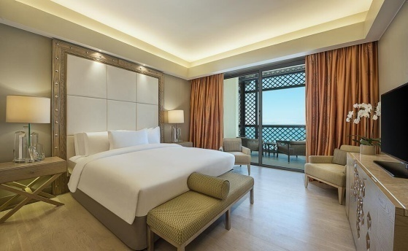
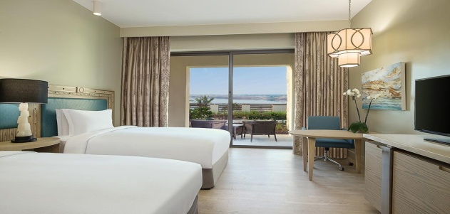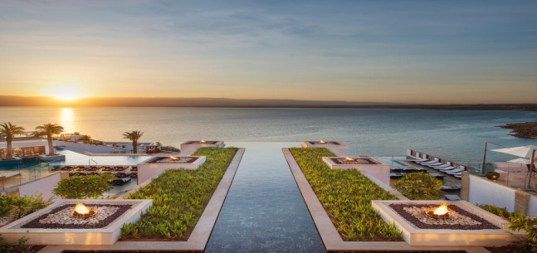
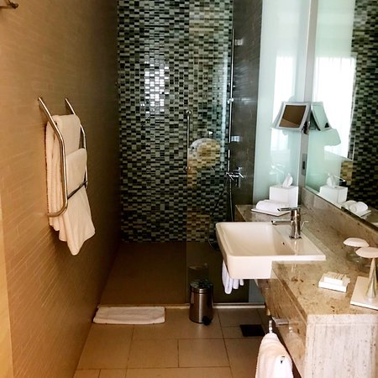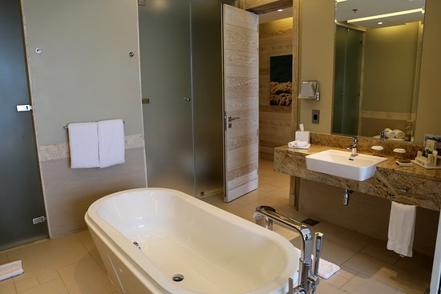

Electricity:
Electrical Current in Jordan is 220V.

Language:
The official language in Jordan is Arabic while English can be used as a second language for necessity. It will be used during all the meetings.

Room rates :

Single Room (€): | 800 Euros for 3 nights’ full board  175 Euros per extra nights full board
Double Room (€): | 770 Euros for 3 nights per person full board  150 Euros per extra nights per person full board

- If you require an invoice please contact : jasser.jopc@hotmail.com

Bank account:

National Paralympics Committee: Jordan Paralympics Committee
Jordan Sport Federation For The Handicapped | Account Name
Amman-Jordan - P.O.BOX (960562) | Address
The Housing Bank For Trade & Finance | Bank
Almadenah Alreyadyah | Branch
JO08 HBHO 0160 0000 0006 7000 2010 01 | IBAN
00000 67000201001 | Account NO ($)
HBHOJOAXXXX | SWIFT of Beneficiary

Post Offices:
Office services available in the hotel, Delegates can send their Post Cards through it or they can ask the volunteers for assistance.

Communications (WIFI)
WIFI is available free in hotel and meetings halls, and available in all rooms.

Sanitary Facilities
Wheelchair users are provided for at the hotel.

Important Dates:
1 September 2021 | Deadline for Registration
9/10/2021 | Participants arrival
10/10 /2021 | meetings
11/10 /2021 | meetings
12/10 /2021 | Departure
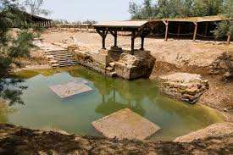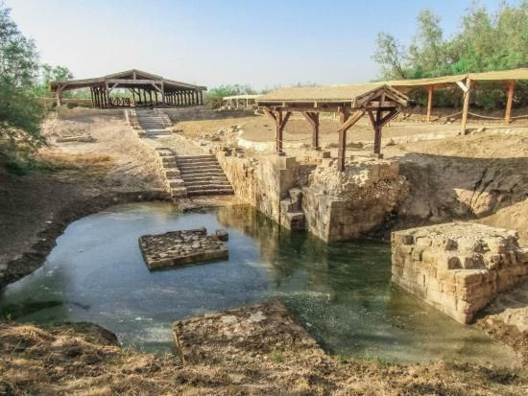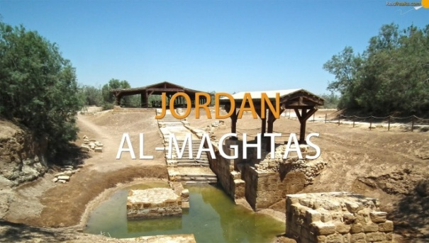

Social Activities
There will be a trip arranged in the programme to visit the site where Jesus was baptized (ALMAGTAS). See above photos.

Please respect the deadline of 1 September for registering your participation. For those who require a visa that also would be the final date for sending the following documents:
1- visa request form
2- copy of their passports
3- their photographs
4- The proof payment of the accommodation fees

Contact person: Jasser nuweiran , Email : jasser.jopc@hotmail.com

Important mobile Numbers:
- The Jordan Paralympic committee
00962656611774 / 5

- Ms Maha Barghouthi , Secretary General of Jordan NPC
Mobile: 00962795533002

- Mr.Jasser Nuwiran , Executive committee president
Mobile: 00962 795722775

- Mr.Daoud Shehadeh,Manager of Prince Raad Bin Zeid complex Mobile : 00962795700774

- Mr.Ahmad Hyasat , Tournament Coordinator
Mobile: 0096277765104

- MRS Rasha Alkhayyat
Mobile: 00962790918704

COUNTRIES WHO NEED VISAS IN ADVANCE OF ARRIVING IN JORDAN

AddThis Sharing Buttons

Restricted Countries – Asia Continent
No. | Restricted Countries – Asia Continent
1 | Islamic Republic of Afghanistan
2 | Islamic Republic of Iran
3 | Independent State of Papua New Guinea
4 | Islamic Republic of Pakistan
5 | Democratic Socialist Republic of Sri Lanka
6 | Republic of the Philippines
7 | Socialist Republic of Vietnam
8 | Kingdom of Cambodia
9 | Lao People’s Democratic Republic
10 | Mongolia (Republic of Mongolia)
11 | Republic of the Union of Myanmar
12 | Kingdom of Nepal (Federal Democratic Republic of Nepal)
13 | Republic of Iraq
14 | Republic of Yemen
15 | Republic of bangladish

Restricted Countries – Africa Continent
No. | Restricted Countries – Africa Continent
1 | Republic of Ethiopia
2 | State of Eretria
3 | Central African Republic
4 | Republic of Angola
5 | Republic of Uganda
6 | Republic of Botswana
7 | Republic of Benin
8 | People Democratic Republic of Burkina Faso
9 | Republic of Burundi
10 | Republic of Chad
11 | United Republic of Tanzania
12 | Togolese Republic
13 | Republic of Djibouti
14 | Democratic Republic of the Cong (Zaire)
15 | Republic of Zambia
16 | Republic of Cote d’Ivoire (Ivory Coast)
17 | Republic of Senegal
18 | Republic of South Sudan
19 | Republic of Sierra Lion
20 | Federal Republic of Somalia
21 | Gabonese Republic
22 | Republic of the Gambia
23 | Republic of Ghana
24 | Republic of Guinea
25 | Equator Genie Republic
26 | Republic of Guinea-Bissau
27 | Republic of Cameroon
28 | Republic of the Congo
29 | Republic of Liberia
30 | Republic of Mali
31 | Democratic Republic of Madagascar
32 | Union of the Comoros
33 | Islamic Arab Republic of Mauritania
34 | Republic of Mozambique
35 | Republic of Namibia
36 | Republic of Niger
37 | Federal Republic of Nigeria
38 | Republic of The Sudan
39 | Libya

Restricted Countries – Europe Continent
No. | Restricted Countries – Europe Continent
1 | Republic of Albania
2 | Republic of Moldova

Restricted Countries – South America Continent
No. | Restricted Countries – South America Continent
1 | Belize
2 | Republic of Cuba
3 | Republic of Colombia

