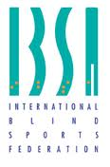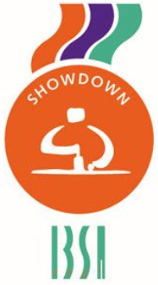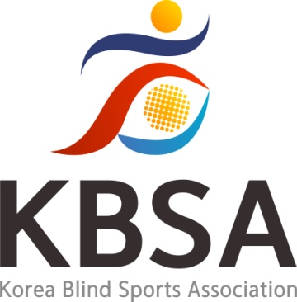

IBSA SHOWDOWN SPORT COMMITTEE
in cooperation with
KOREAN BLIND SPORTS ASSOCIATION

presents
ASIA NATIONAL REFEREE COURSE

Seoul, 5th – 8th December 2023

About Showdown – Sports Committee
Chair
Artūrs Kalniņš
E-mail: showdown.chair@ibsasport.org

Vice Chair
Elena Santini
E-mail: elena.santini1984@libero.it

Referees' Representative
Jonas Riester
E-mail: jonas.riester@web.de

Coach Representative
Akseli Makkonen
E-mail: akseli.makkonen@gmail.com

Athletes' Representative
Christoff Eilers
E-mail: christoff.eilers@gmail.com

Asia Representative
Kang Ho Yong
Phone: +82 02 400 6335
E-mail: ghy3090@hanmail.net

Organizer for the Korea Blind Sports Association
IBSA KOREA
A-1301 ,583, Yangcheon-ro, Gangseo-gu, Seoul, Republic of Korea
Tel : +82 02 400 6335
web : http://kbsa.koreanpc.kr/
E-mail: kyungk21@naver.com

We look forward to meeting and welcoming you to Korea.
Should you have any questions regarding this event, please contact us at: kyungk21@naver.com
Important Registration Deadlines

*PLEASE RESPECT ALL DEADLINES AND RULES DETAILED BELOW*

Entry forms submitted after the deadline will not be accepted and will result in the IBSA Member not entering the Event.
Submit the final entry after the participant is confirmed.
If there are many participants, participation may be restricted.

1. First Entry Submission Deadline: November 20, 2023
2. Participant Confirmation Date: November 20, 2023
3. Final entry Submission Deadline: November 25, 2023

Entry Fees

Entry Fee: $350.00 per person
Entry Fee Payment Deadline: November 29, 2023

Participant will be charged an entry fee of $350 dollars.
The entry fee includes accommodation* and meals from 4th to 9th December 2023, ground transportation to/from approved airports to the Official Hotel and Referee Course venues.
The entry fee does NOT include air transportation fees for delegation members. Delegations may only stay at the official hotels during the Referee Course period.

*Rooms will be assigned to 2 people per room. If you wish to request a single room the extra fee is $100.

Arrivals & Departures

We will pick up your Delegation on the following days at the designated airports.
If arriving on a different day or airport than what is listed below, you are responsible for transportation to Incheon International Airport.

Arrival on December 4th, 2023
Departure on December 9th, 2023

Airport Information

Incheon International Airport

Terminal 1 272, Gonghang-ro, Jung-gu, Incheon, Republic of Korea 22382
Terminal 2 446, Je2terminal-daero, Jung-gu, Incheon, Republic of Korea22382

For more information, visit https://www.airport.kr

Event Venue
Hotel Bernoui ( Seminar Room)
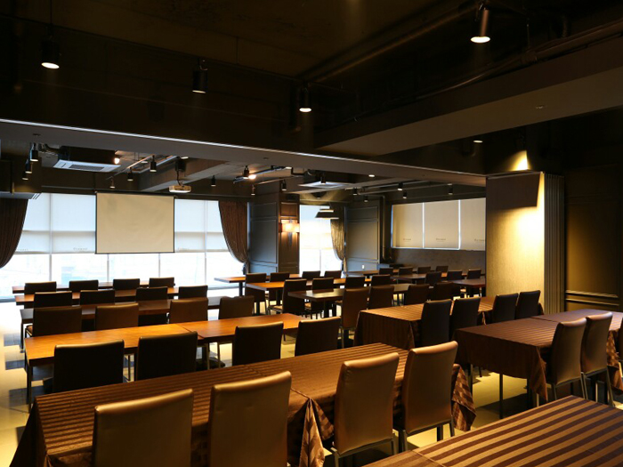

Hotel Information
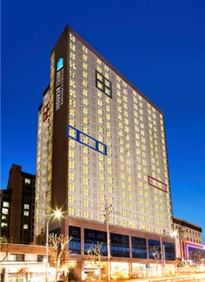

Hotel Bernoui

229, Gyeongin-ro, Guro-gu, Seoul, Korea
http://www.hotelbernoui.com/

* Each nation must provide a credit card to the hotel upon check-in for any incidentals (room service, etc.) or damages.

If you are a member of a participating delegation or have questions about accommodations, please email kyungk21@naver.com.

Course Information

The National Referee Course and Exams will be held in English.
Participants have to speak English well or, if not, must be accompanied by an interpreter at their own expenses.

Showdown National Referee Course Program

5th December 2023
09:00-10:00 Presentation and Introduction to Showdown
10:00-11:00 Explanation of the Rules
11:00-11:30 Break
11:30-13:00 Explanation of the Rules
13:00-14:00 Lunch Break
14:00-16:00 Explanation of the Rules
16:00-16:30 Break
16:30-18:00 Explanation of the Rules

6th December 2023
09:00-11:00 Explanation of the Rules
11:00-11:30 Break
11:30-13:00 Scoresheet Explanation and Exercises
13:00-14:00 Lunch Break
14:00-16:00 Demonstration and Practice
16:00-16:30 Break
16:30-18:00 Practice

7th December 2023
09:00-11:00 Practice
11:00-11:30 Break
11:30-13:00 Practice
13:00-14:00 Lunch Break
14:00-16:00 Practice
16:00-16:30 Break
16:30-18:00 Practice

8th December 2023
09:00-10:00 Questions and Answers
10:00-11:00 Written Exam
11:00-11:30 Break
11:30-13:00 Practical Exam
13:00-14:00 Lunch Break
14:00-16:00 Practical Exam
16:00-16:30 Break
16:30-17:30 Practical Exam
17:30-18:00 Evaluation of the exams and Certification delivery

