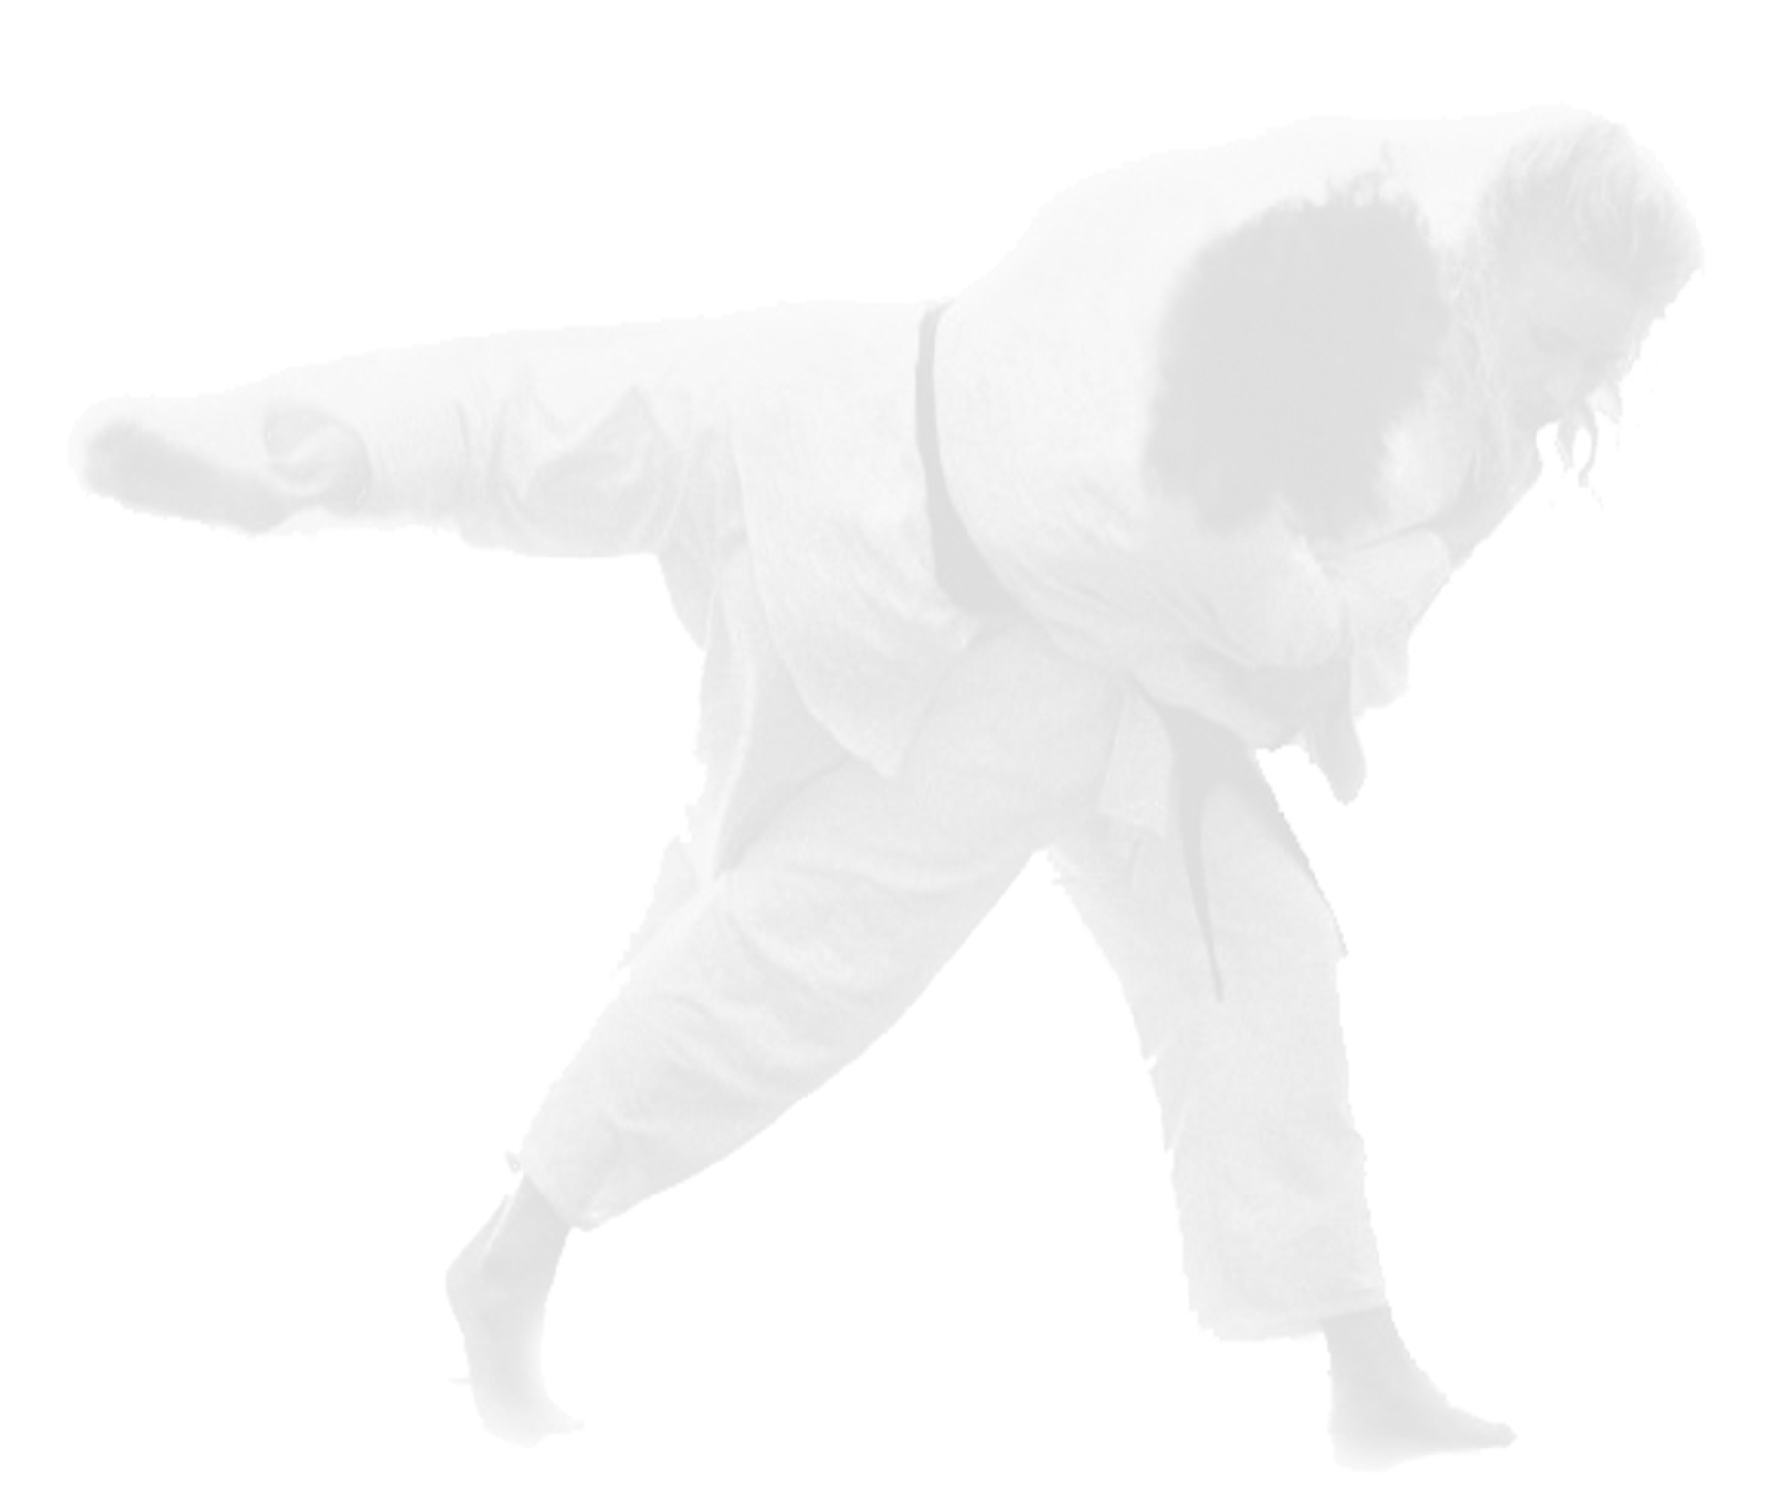
1. ORGANISER
Event Outlines
Dutch Open Venray Tournament 2025
Netherlands

Dutch Open Adapted and VI Judo Tournament
November 13st – 17st 2025

Sportinstituut Verhagen – Judo For All Nederland
Address: Venray Heuvelstraat 9b 5801CS Venray
Email: dutch.open.venray@gmail.com
Tel: +31 622136206

Emergency Contacts:
General matters: ; dutch.open.venray@gmail.com
Accommodation: ; dutch.open.venray@gmail.com
Transport: ; dutch.open.venray@gmail.com

Judo Bond Nederland
Address: Kelvinbaan 48, 3439 MT Nieuwegein
Email: info@jbn.nl
Tel: +31 30 707 36 00

2. IMPORTANT INFORMATION
Before Travelling
Passports must be valid for at least 6 months from the date of arrival.
• Check host country entry requirements and airline requirements (if applicable).
• Check if you need a visa, and if yes, make request from the LOC.
• Send travel information (arrival and departures) to the LOC.

Entering host country
Each individual is responsible to ensure they follow the entry rules (passport validity, visas, entry permission letter, etc.) for the host country.

Insurance
It is the responsibility of each participant to ensure that in addition to their normal insurance they have sufficient insurance in place to cover any pandemic related costs, including repatriation. The LOC of the event and the EJU accept no liability for any claims relating to cancellation of the event due to any pandemic or medical costs for any illness that may affect them during the event.

3. COMPETITION VENUE
Sporthal de Wetteling Venray
Address: Zuidsingel 2, 5802 EG, Venray

4. AGE
Under 15 (Born in 2010 until 2019)
Competitors grouped into pools with a minimum of 2 contests and maximum age difference of three years between).
Over 15 years old (Born in 2009 and older)
Consideration of pools will be given within divisioning and the discretion of the Tournament Director.

5. PARTICIPATION

This Dutch Open tournament is open for all clubs and EJU/IJF Member Federations. In case of pandemic outbreak restrictions for the number of participants may apply.

6. CATEGORIES

The weight classes described in the IJF rules are only strictly observed with Levels 1, 2, 3 and VI (over 15 years old). The tournament director determines the allowed weight margin during the weigh-in procedure. At Levels 4 and 5, weight, experience and abilities are considered when divisioning and weighing in.

7. ENTRY FEE

The EJU entry fee of 20€ per athlete must be paid.

8. DEADLINES

Hotel Reservation: Sunday 13th October 2024

Competition Registration: Sunday 13th October 2024

Travel details: Sunday 13th October 2024

9. PROGRAM

Attention: The schedule may be modified according to total number of entries and circumstances of competition. The start of the tournament will be confirmed once the final number of athletes is known.

Thursday 13 st November
Times to be confirmed | Arival L1,L2,L3 and VI (2009 and earlier)
Friday 14 st November
Times to be confirmed | Arival L4, L5, VI and al born 2010 – 2019 | De Wetteling
 | Weigh in/accreditation | De Wetteling
 | Divisioning only L1,L2,L3 and VI (2009 and earlier) | De Wetteling
 | Coach Meeting | De Wetteling
 | A-VI judo training all levels 2009 and earlier | De Wetteling
Saturday 15nd November
Times to be confirmed | Event Dutch Open A-VI | De Wetteling
 | Dinner Party | Asteria
Sunday 23rd November
Times to be confirmed | Training A-VI all levels Morning | De Wetteling
 | Training afthernoon | Dojo
 | Departure
Monday 24th November
A-VI training all levels Dojo
Departure

10. REGISTRATION

All participants and delegates must be registered for this event via: dutch.open.venray@gmail.com

Deadline for Competition Registration is Sunday 13th October 2024.

11. COMPETITION MODE

The competition will be conducted in accordance with the EJU Adapted Judo Rules.

Levels 1, 2, 3 and VI (over 15 years old): 3-minute contest, unlimited Golden Score.
1-5 competitors (pool)
6-10 competitors (Pool, crossover)
Over 10 competitors (double repechage)

All U15 categories and levels; and Levels 4 and 5 (over 16): 2 or 3 minute contest, No Golden Score. Decision at the end of contest time. Times at the discretion of Tournament Director and ability levels. 1-5 competitors (pool).

12. DRAW

The draw for L1,L2,L3 and VI (2009 and earlier) will be held after divisioning.

13. WEIGH-IN

Official weigh-in is held before the competition day (see program).
Athletes are not allowed to weigh-in naked. Boys must wear at least underwear and girls at least underwear and a T-shirt. Additional 200g will be allowed for their weight category limits.
Athletes must present their passport (National ID Cards showing nationality, picture and date of birth are also accepted).
Official scales or test scales will be available for test weigh-in on Saturday from 09:00 – 17:00 in the Sports hall.

14. TRANSPORT

Airports:
If you fly over to the Netherlands, we can pick you up from the following airports at a shuttle service fee of € 50,- per person:

- Eindhoven Airport
- Düsseldorf International
- Düsseldorf/Niederrhein Weeze.

The shuttle is only offered if you are staying at the official hotel. Should you chose to stay somewhere else, please arrange transport from the airport to your hotel/accommodation.

If you arrive at/depart from Amsterdam (Schiphol) airport (or want to travel by train anyway), we kindly ask you to take a train to Venray-Oostrum or Deurne station. From there we can pick you up as well.

Please inform us about the total amount of people that use the shuttle service (judoka, trainer/coach, carers, parents).

The details of their arrival must be communicated to the organiser for the transport organisation via email: ductch.open.venray@gmail.com

15. ACCOMMODATION

Hotel reservations will be made by yourself. There are only transport from the airport to the official hotels and to and from the event. If you chose to stay at another hotel or accommodation then you must arrange transport yourself.

Hotel Asteria
Address: Maasheeseweg 80A, Venray

Hotel Hulsman
Address: Henseniusplein 9, Venray

16. PAYMENT

Kindly complete the payment for entry fee (and transport if booked) to our bank account:
Bank Address | Leidseveer 30, 3511 SB, Utrecht
Bank Name | Rabobank Nederland
Name of account holder: | Stichting Judo for All Nederland
IBAN: | NL73 RABO 0318 2398 33
SWIFT: | RABONL2U
Payment reference | Dutch Open 2025 and name of the club.

The deadline for paying the fee (and transport) is Sunday 13th October 2024.
All bank fees and money transfer costs must be paid by the sender club or federation. The person attending registration must bring proof of the bank transfer.

Please, be careful with the fraudulent emails. Always check the bank details from the outlines.

17. JUDOGI AND AIDS
- Only white judogi can be used.
- Aids are considered outside the standard Judo uniform as described in the IJF Tournament Regulations.
- The Judogi must be adjusted to the physical limitations of the judoka; however, it must not hinder the opponent from performing proper judo technique.
- Wearing socks with rubber grip dots in Ne-waza is allowed for medical reasons.
- Wearing a plain white round-neck T-shirt under the judogi is mandatory for female athletes. For male athletes, plain white T-shirts may be worn.
- Wearing a mouthguard is allowed and meets regulations.
- Aids must be safe for both the wearer and the opponent and cannot contain hard substances or surfaces, to be decided at the discretion of the main referee.
- The opponent may not be disadvantaged, nor may the wearer have an unreasonable advantage from the aid. Glasses cannot have hard surfaces and must fit flush to the face. Sports glasses are allowed once authorised by the tournament director and under the condition that they do not present a risk to either athlete.

18. RESPONSIBILITY OF CLUBS AND FEDERATIONS
The competitors will compete under the full responsibility of their clubs or federations. The European Judo Union and the organiser decline all responsibility.

Consent for Photography/Videos/Filming
Delegates inscribed by their Clubs or National Federations for EJU events consent to the EJU and its media partners to use content of them, including data, live results, photographs and/or video recordings (hereafter referred to as Media). This media may be obtained from National Federations and EJU. It will also be acquired by the EJU and its media partners from in and around all EJU event venues. Media could be used in print and digital media formats including print publications, websites, e-marketing, posters banners, advertising, film, broadcast, social media, education purposes and other purposes. The National Federation and Clubs must ensure that they have the permission of each delegate or in the case of a minor the permission of the parent/guardian. If a delegate does not give consent, then the National Federation or Club must inform the European Judo Union by writing to headoffice@eju.net.

19. MEDIA
Journalists can apply for Media accreditation online using.

20. VISA
The LOC will assist with visas where possible but having the correct visa is the responsibility of each participant. Evenementen@jbn.nl

For everything that is not covered by these outlines, the EJU Adapted judo rules apply!

