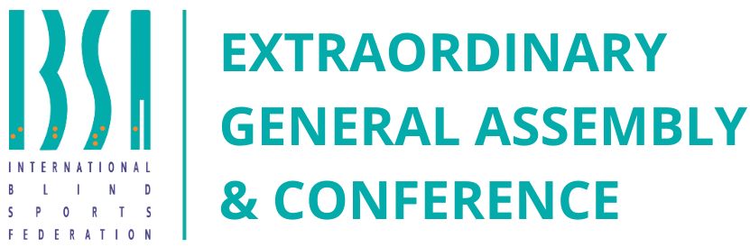

**Invitation Package**

**Antalya, Türkiye | 25–26 October 2025**

Dear friends, esteemed IBSA members, delegates, and honored guests,

It is with great excitement and pride that I invite you to participate in the IBSA Extraordinary General Assembly & Conference, which will be held on 25–26 October 2025 in the sunny and welcoming city of Antalya.   
This is a time of decisive change and new horizons — a time when together we can write a crucial chapter in the history of our organization. Your presence is not just participation; it is a living testament to the strength of our community, a symbol of unity and shared faith in sport that transforms lives.   
Only by coming together, with the overwhelming majority of us united, can we overcome any challenges and make IBSA even stronger, more transparent, and more inspiring. We stand on the threshold of great change, and our cohesion is the key to making that change successful.

Before us lie two vital tasks:   
1. **Updating the IBSA Constitution.**  
 We will strengthen the foundation on which our organization is built, making it more flexible, modern, and ready to meet the challenges of the future.   
2. **Defining the core goals of IBSA’s strategic development for the near future and the long-term perspective.**  
This is our beacon and map that will guide us forward, uniting our efforts and inspiring new achievements in sport for the blind and visually impaired.

I urge each of you to fully unlock your potential — bring your voice, your ideas, and your heart to this process. Together, we are not merely creating plans — we are shaping a future that will inspire thousands of athletes around the world.   
I would also like to extend special thanks to our Turkish friends and hosts for their warm hospitality and impeccable organization of this important meeting. Antalya is the perfect place for new dreams to take root and new opportunities to arise.

Let us step into this future together, shoulder to shoulder — with determination, faith, and an indomitable spirit of unity. Together, we will make IBSA stronger, brighter, and closer to every athlete!   
Thank you for your attention. Welcome to the IBSA Extraordinary General Assembly & Conference!

**Ilgar Rahimov  
IBSA President  
 @RahimovIlgar**

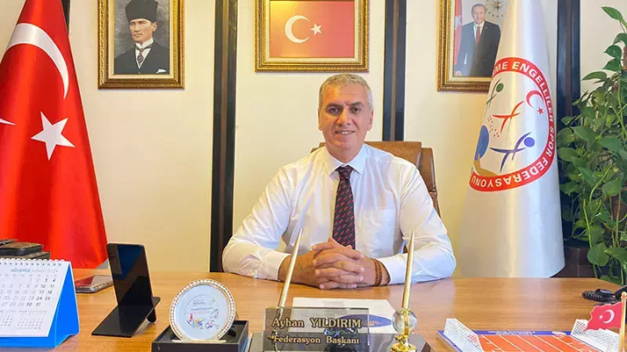Dear friends, esteemed IBSA members, delegates, and honored guests, On behalf of the city of Antalya and the entire host team, it is our sincere pleasure to welcome you to the IBSA Extraordinary General Assembly & Conference.

Antalya is not just a city rich in history and breathtaking nature — it is a place where hearts meet and new hopes are born. We are proud to be your warm and reliable home during these special days.

We will do everything possible to ensure your work is comfortable and productive, and that the atmosphere is friendly and inspiring. Here, along the sunny shores and with warm hospitality, you will not only focus on important decisions but also feel the support and unity so vital for the growth of IBSA.

May these days become a time of new ideas, strong partnerships, and confident steps toward a bright future for sport for the blind and visually impaired.

Welcome to Antalya — the city of open hearts and great opportunities!

**Ayhan YILDIRIM**  
**President of the Turkish Visually Impaired Sports Federation**

**Event Program**

|  |  |
| --- | --- |
| **Date** | **Activity** |
| 24 October | Arrival of delegates |
| 25 October | General Assembly – Day 1 (from 09:00) |
| 26 October | Conference – Day 2 (from 09:00) |
| 27 October | Departure |

**Accommodation Details**

**Venue:** Ramada Plaza Antalya ([Link](https://ramada-plaza-antalya.foxtatil.com.tr/?gad_source=1&gad_campaignid=21945759270&gbraid=0AAAAA9_PcOaWDXU4LW88BDsVpzPvLSpxB&gclid=Cj0KCQjwu7TCBhCYARIsAM_S3Nh10yKDiMXqSPKEZTGpSaRM8AkR9E023A6-5OYjUC1-gyAZxsS-DBgaAqRuEALw_wcB))  
**Address:** Gençlik Mah. Fevzi Çakmak Cad. No:22, 07100 Muratpaşa/Antalya, Türkiye  
**Board Basis:** Ultra All-Inclusive

|  |  |
| --- | --- |
| **Room Type** | **Rate (per person, 3 nights)** |
| Single Room | €650 |
| Double Room | €550 |
| Additional Day (Single Room) | €235 |
| Additional Day (Double Room) | €195 |

***Note: Rates cover accommodation, meals, and beverages per the hotel’s Ultra All-Inclusive policy.*   
  
50% of the cost of the stay must be paid by August 15, 2025. After this date, the prices will apply as indicated in the table below.**

|  |  |
| --- | --- |
| **Room Type** | **Rate (per person, 3 nights)** |
| Single Room | €800 |
| Double Room | €700 |
| Additional Day (Single Room) | €285 |
| Additional Day (Double Room) | €245 |

**Participation Fee:**

For delegates €250 per participant

For accompanies €150 per participant

**Covers:**

· Assembly & conference sessions

· Audio-visual equipment and materials

· Coffee breaks and snacks

· Airport transfers

· Cultural program and welcome evening

**Visa Information**

**Visa-Exempt Countries**  
 Citizens of many countries may enter Türkiye visa-free for 90 days within any 180-day period. This includes:  
 *Austria, Brazil, France, Germany, Japan, Morocco, United Kingdom, and many others.*

**e-Visa Eligible Countries**  
 Citizens of countries such as:  
 *Australia, Canada, China, India, United States, South Africa, UAE*  
 can apply for an **e-Visa** online: <https://www.evisa.gov.tr>

**Conditional e-Visa**  
 Available to citizens from select countries (e.g., Afghanistan, Bangladesh, Pakistan) with valid Schengen, US, UK, or Ireland visas/residency.

**Visa Required**  
 All other nationals must apply at a Turkish embassy/consulate. Full information at: <https://www.mfa.gov.tr>

**Registration & Booking**

1. Fill out the **Mandate Form** (signed and stamped by your national federation: **attached to the email (deadline – August 5, 2025)**

2. Complete the **Online Registration Form**: [Link](https://preview--antalya-assembly-wizard.lovable.app) **(deadline – August 5, 2025)**

3. If you have any **Motion** for EGA 2025 please fill out the **Motion Form: attached to the email (deadline – July 25, 2025)**

**Payment Terms**

· **50% accommodation cost** due by: **August 15, 2025**

· **Remaining 50%** by: **October 15, 2025**

· **Participation fee (100%)** by: **October 15, 2025**

*Bank details for payment will be sent by email after registration.*

**Contact Information**

For inquiries about accommodation, visa support, transfers, or registration:

**IBSA:** [**ega2025@ibsasport.org**](mailto:int.comp.gesfed@gmail.com)

**LOC:** [**int.comp.gesfed@gmail.com**](mailto:int.comp.gesfed@gmail.com)

**We look forward to welcoming you in Antalya!**

Your participation will be vital in shaping the future of blind sports and strengthening our global community.